Performance Analysis of a Concurrent Fire detection and Alarming system

## Prashaanth R. M.

M.Tech Real Time Embedded Systems, Dept. of CSE M S Ramaiah University of Applied Sciences Bangalore, INDIA

[ajuprashanth06@gmail.com](mailto:ajuprashanth06@gmail.com)

## Jishmi Jos Choondal

Assistant Professor, Dept. of CSE

M S Ramaiah University of Applied Sciences Bangalore, INDIA

[jishmi.cs.et@msruas.ac.in](mailto:jishmi.cs.et@msruas.ac.in)

***Abstract*— Technology isn’t in the same plate where it was in 1980’s or 90’s. It has increased in the linear fashion. Embedded Systems surround us in the form of gadgets and devices that we use. Embedded systems has brought in a new era called Real Time Embedded systems which has in turn brought in Real Time Applications. Real Time application are being achieved using Real Time threads, threads are nothing but processes. There are many programming languages with multithreading capabilities available like C, C++, Java, Python, Go, Ada, etc. But there are few things to consider here for Real Time Application, the compatibility with controllers and other hardware components. In this paper a Fire Detection and Alarming system will be designed and developed using both C++ and MicroPython. The system will be developed on ESP32 board using software FreeRTOS, which is compatible with both C++ and Micropython languages. System will be developed in 4 different ways sequentially using C++, Micropython and multithreading using C++, Micropython. Different parameters like execution time, memory consumption, latency, WCRT and Jitter will be examined and compared with Benchmark application.**

***Keywords— FreeRTOS; Micropython; performance analysis; latency; WCRT; Jitter; Execution time.***

1. INTRODUCTION

The current generation is being filled with variety of Embedded systems. Starting from your Television, mobile phones, washing machine etc all are an embedded system. The concept of embedded system was formed in 1965 from the Computer there is where everything started. These systems have reduced two things one is manual work and another is the time taken for completion. Slowly when comparing the old computer and the one today there are a lot more differences like size, features, speed etc. This major drift has been carrying out speed all over the years. Speed is being achieved using powerful hardware and optimized and well-written firmware. There has been improvement from single-core to multi-core processors in the architecture of the hardware systems. Not only that even mobile phones are like a mini computer today which is achieved using Octo-core processors. Major drift in speed is majorly concentrated since due to fast life people do not have that much time for wasting in opening different applications in a computer or a mobile phone or it may be any embedded device. To a greater extent improvisation on hardware has made software to upgrade concurrently. Strictly bringing in many features to the system has brought in many interrupt that is being solved using multithreaded programming.

Multithreaded programming contains two or more threads that are running concurrently and always looking for a time-saving notion. An interrupt will react like a process and a corresponding scheduler will be assigned to perform it. This gave birth to real-time applications which are time deterministic and the system should complete the corresponding task within the specified given time. Real-time application is being used in Automotive, aerospace, military, gaming, Server creation, space shuttle etc. When the real-time application came up it was challenging to achieve the time deterministic nature using a general-purpose operating system so, for this, a Real-time operating system was required. The first operating system was launched way back when Apollo 11 shuttle was made and it was the AGC computer weighed in at 30 kg, ran at 1MHz and only had 74Kb of ROM and 4Kb of RAM but now we have many RTOS like Xenomai, VxWorks, FreeRTOS, OSEK, QNX, LynxOS etc.

There are many differences between RTOS and GPOS right from their scheduling, priority, threads, memory utilization etc. General purpose operating systems cannot perform real time tasks whereas RTOS is suitable for real time applications. Latency is a problem with GPOS but it is overcome using real time OS. Priority inversion cannot be done in GPOS, it is done with real time kernel. Different programming languages have different capabilities and there are many languages like C, Java, C++, python etc that has multithreading capabilities and the real-time capabilities are added in different ways in each programming language. This paper focuses on developing real-time application using different languages like C++ and Python with the analysis on their performance with the benchmark application. This paper includes the details of background theory, methodology and results in the following sections

1. BACKGROUND THEORY

Water quality is mainly affected by microbial and non- microbial parameters. Most of the non-microbial parameters can be analyzed relatively quickly, at lesser cost and can be measured on-line, automated to provide real time data that can be linked to event detection algorithms using simulations [7],

[6] to trigger alarms at unusual events[5] such as contamination in water. Non-microbial parameters include rainfall events, flow and color of water, pH, Total Dissolved Solids (TDS), conductivity, chlorine contents etc. This paper focuses on testing or monitoring water quality parameters like pH, Conductivity, TDS, Temperature.

1. *pH*

pH is defined as the measure of the amount of alkalinity or acidity in drinking water, which is basically the measurement of hydrogen ion concentration in water. pH analysis helps in wide range of applications like industrial or domestic applications. It varies from waste water treatment process to

conditioning of water for industrial processes. Monitoring the drinking water pH is important due to many reasons like: in human body, metabolic process cannot withstand imbalanced pH [1]. Any variations in pH in biological fluids can even lead to toxin production in body and weaken body’s ability to produce enzymes and hormones that can lead to problems in central nervous system [1]. It can also affect electro- physiological activity of brains, capable of altering enzyme shapes resulting in failure in the normal functioning of metabolic activities of human body. pH measurement can be done using combined glass electrode principle, were hydrogen ions in the solution migrate through a selective barrier, producing a measurable potential (voltage) difference proportional to the solution’s pH value. pH of drinking water should be between 6.5 to 9 [7].

1. *Conductivity*

Water conducts electricity when salts are dissolved in them. It is determined by measuring the concentration of the ions or salts dissolved [7]. Conductivity is directly related to the Total Dissolved Solids (TDS) in water. Electrical conductivity of water mainly depends on temperature of water, number of ions or ion concentration in water, its mobility (ion) and oxidation state. Sudden change in conductivity of water can be due to pollution [1]. During a drainage leak or agricultural runoff, the concentration of additional ions such as nitrate, chloride, fluoride and phosphate can increase conductivity but in some cases, where the elements do not break down into ions, conductivity will reduce. Both the cases affect quality of drinking water negatively. Salinity of water contributes to conductivity through water level and water flow changes as well, temperature changes fluctuates the conductivity significantly leading to stratification due change in density of water which makes water harmful for consumption. Pure water doesn’t conduct electricity [2].

1. *TDS*

TDS indicates the presence of organic salts or inorganic salts like potassium, magnesium, sodium, carbonates and bi- carbonates along with minerals dissolved in water. It can be expressed in milli-gram per unit volume of water or in Parts Per Million (PPM). In drinking water, TDS may be found as a result of chemicals used for water treatment, natural sources, by mixing with industrial waste water or sewage waste while transporting water through distribution systems. TDS and conductivity are related, as in, (1) conversion factor is a constant which varies with different salts in water.

*TDS=Conversion factor ×Conductivity of solution (1)*

For sodium chloride, conversion factor is 500 and for potassium chloride, its value is 570. For natural water, conversion factor is 670.

1. *Temperature*

Significant changes occur in water temperature due to chemical reactions that influence conductivity and TDS of water. It can be determined by careful observations. Mobility

of ions and concentration of ions also change conductivity of solution. Temperature is measured in centigrade scale.

1. METHODOLOGY

Modeling is carried out based on the identified approach using software tools like National Instruments Multisim for the parameters like pH, Conductivity, TDS and Temperature. The block diagram of the system is represented in Fig. 1.

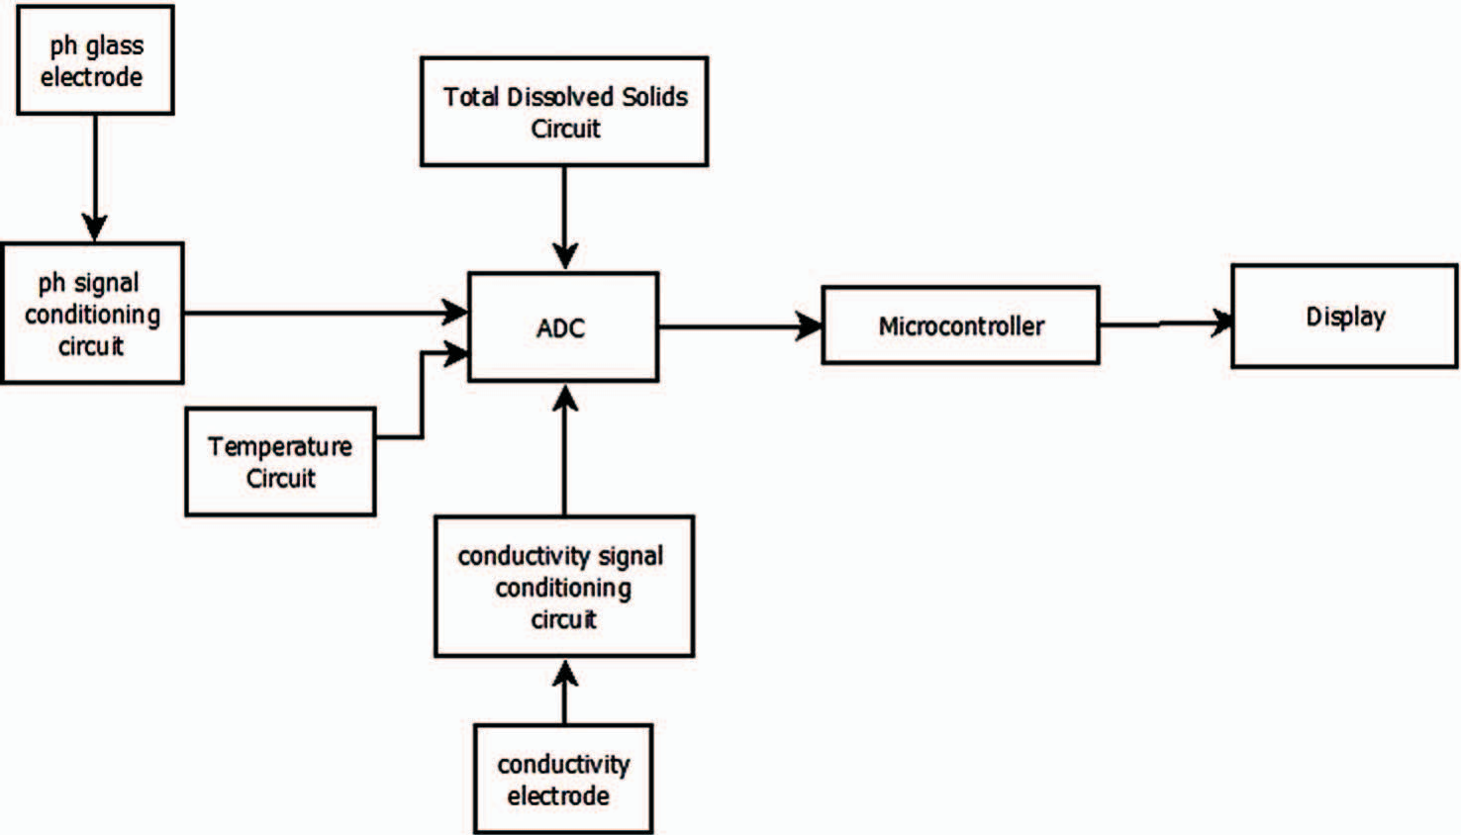

Fig. 1. Block Diagram of the WQM System

The system consists of four sub-systems namely pH measuring sub-system, Conductivity measuring sub-system, TDS measuring sub-system and Temperature sub-system. The outputs from these sub-systems are sent to the Analog to Digital Converter (ADC) of microcontroller and output is displayed on the screen.

1. *pH measuring sub-system*

The block diagram representing the pH measurement sub- system is represented in Fig. 2. The reference electrode in the combined glass electrode always produces a constant voltage which is generated with change in pH of the liquid. The milli- volt output ranging between ±414mV from the pH electrode is sent to a voltage follower using TL081 Integrated Circuit (IC) which follows the input voltage.

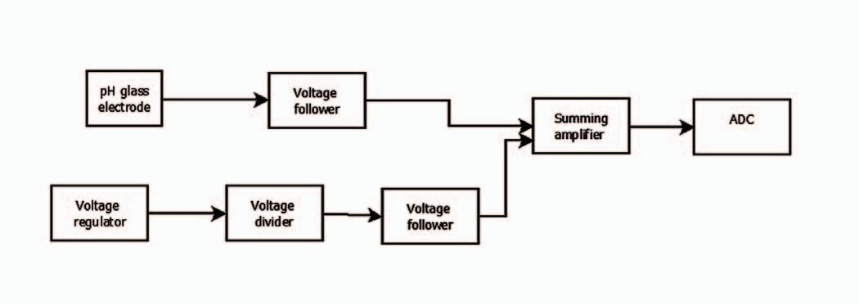

Fig. 2. pH measuring circuit block diagram

The negative voltage cannot be directly given to micro- controller, the voltage has to be added to a threshold value to obtain a positive voltage which can be fed to the microcontroller. By designing voltage regulator circuit using LM317 IC and voltage divider circuit using OP07 IC, the required threshold value can be added to the negative voltage. The summing amplifier is designed using LM741 IC to add up the output voltages from the voltage follower and is sent to

ADC of microcontroller. The circuit simulation is represented in Fig. 3 for the input voltage equivalent to pH of 7.

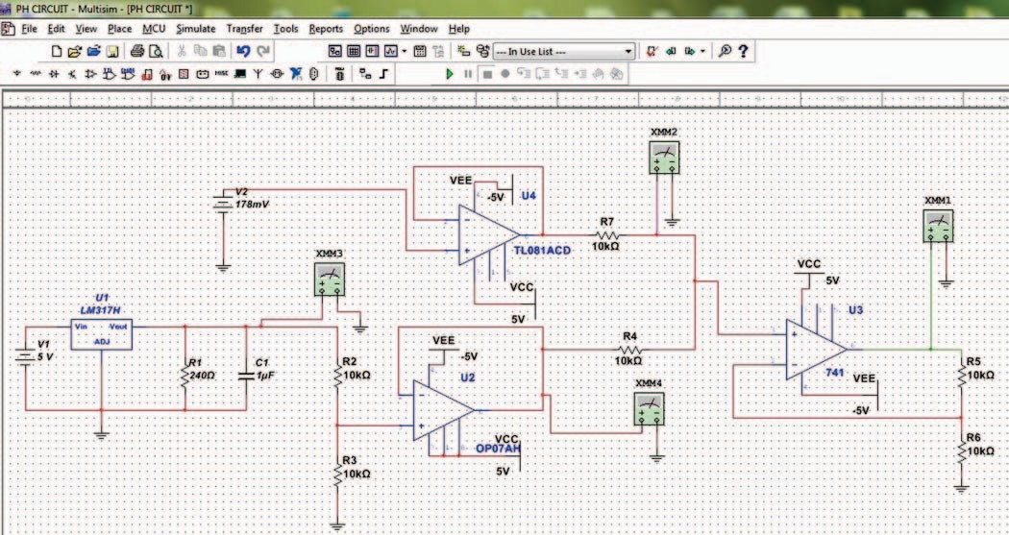

Fig. 3. Ph signal conditioning circuit

1. *Conductivity and TDS measuring sub-system*

The block diagram for conductivity measuring sub-system is represented in Fig. 4. Conductivity electrode is a two cell platinised electrode which measures conductivity by dipping in solution. Alternating Current (AC) is applied to positive terminal of electrode and negative terminal to the gain loop. The output of gain loop is given to rectifier circuit to convert the AC signal to Direct Current (DC) signal. Due to movement of ions between the two electrodes, DC current passes through solution but it cannot be measured using DC signal since the current will split the molecules which conducts electricity into parts making the voltage established across the electrode unstable, leading to difficulty in obtaining the conductivity value.

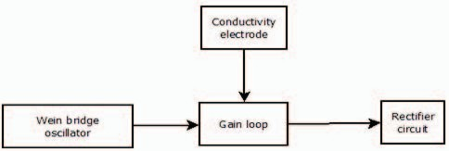

Fig. 4. Conductivity measuring circuit block diagram

But if AC signal greater than 1KHz frequency is used, molecules move just back and forth in its position without splitting the molecules into two since they are pulled back. In order to produce the AC signal, wein bridge oscillator which produces stable output without distortions at lower frequency is used in design. The simulated conductivity measuring circuit designed using TL084 IC is represented in Fig. 5. TDS can also be measured using the above circuit because TDS and conductivity of water are directly related, as in (1).

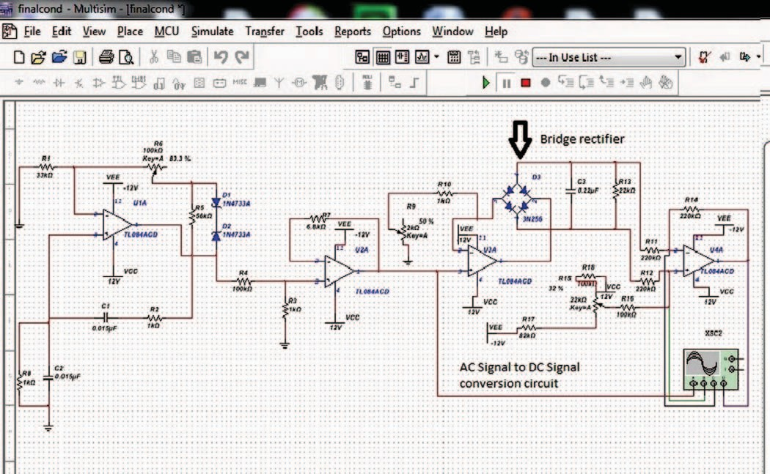

Fig. 5. Conductivity signal conditioning circuit

Units for measuring conductivity are micro- Siemens/centimetre (μS/cm). TDS is measured in milli-gram per unit volume of water (mg/L) or in Parts Per Million (PPM).

1. *Temperature measuring sub-system*

In the temperature measuring sub-system, LM35 temperature sensing IC is converted to waterproof sensor by soldering. The measurements are done in centigrade scale.

1. *Development of the simulated circuits*

The circuits for measuring pH, Conductivity, TDS, Temperature are implemented on hardware and performance is analyzed. Microcontroller used in design is Arduino UNO. To measure the temperature of water, LM35 is converted to a waterproof sensor represented in Fig. 6 at home.

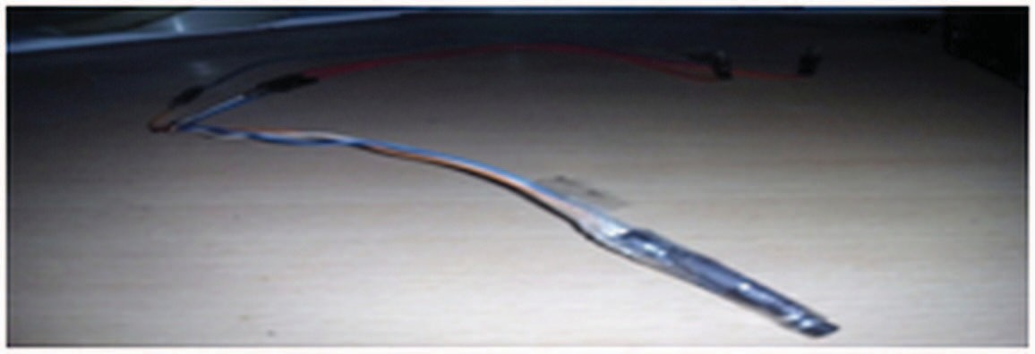

Fig. 6. Temperature sensor

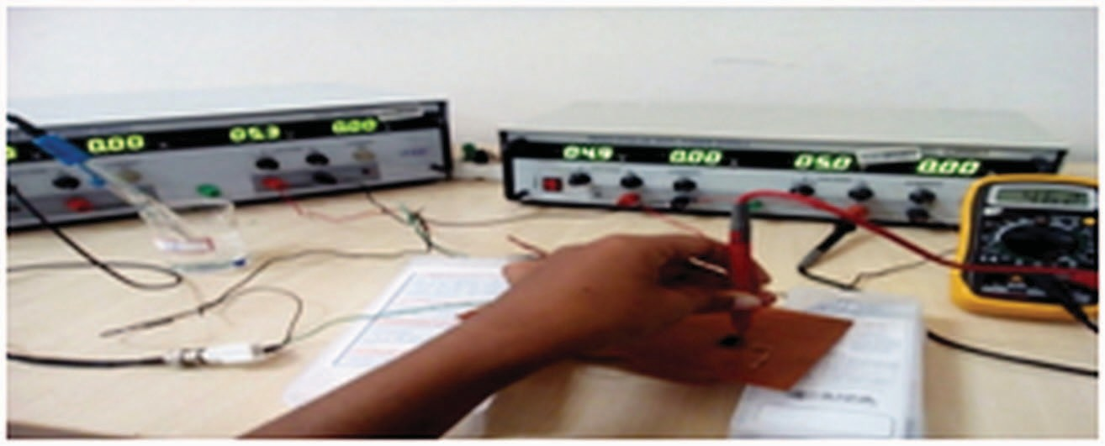

Fig. 7. Ph measuring circuit

pH and conductivity measuring circuits represented in Fig. 7-8 is developed using hardware components like Printed Circuit Board (PCB), ICs’, active and passive components.

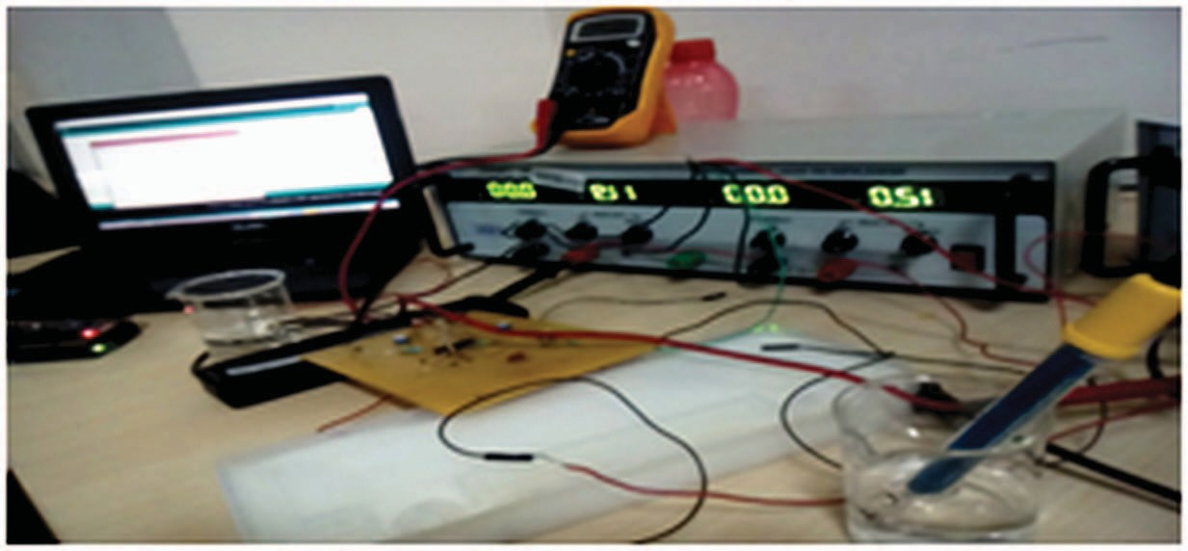

Fig. 8. Conductivity measuring circuit

The pH electrode used is combined glass electrode and conductivity electrode is platinized electrode. Calibration is done for both the electrodes using pH tablets for pH electrode and potassium chloride solution for conductivity electrode. Calibration of pH electrode was based on two-point calibration procedure.

1. RESULTS
2. *Simulation Results*

The simulation results obtained from the software tool Multisim software and Hardware implementation results are discussed in this section of the paper. The pH measuring circuit produces the output voltages represented in Fig. 9 for pH value of 4. The voltage regulator IC produces 1.25Volts (V), voltage divider IC produces 625mV and DC power supply is used to supply voltage corresponding to pH value.

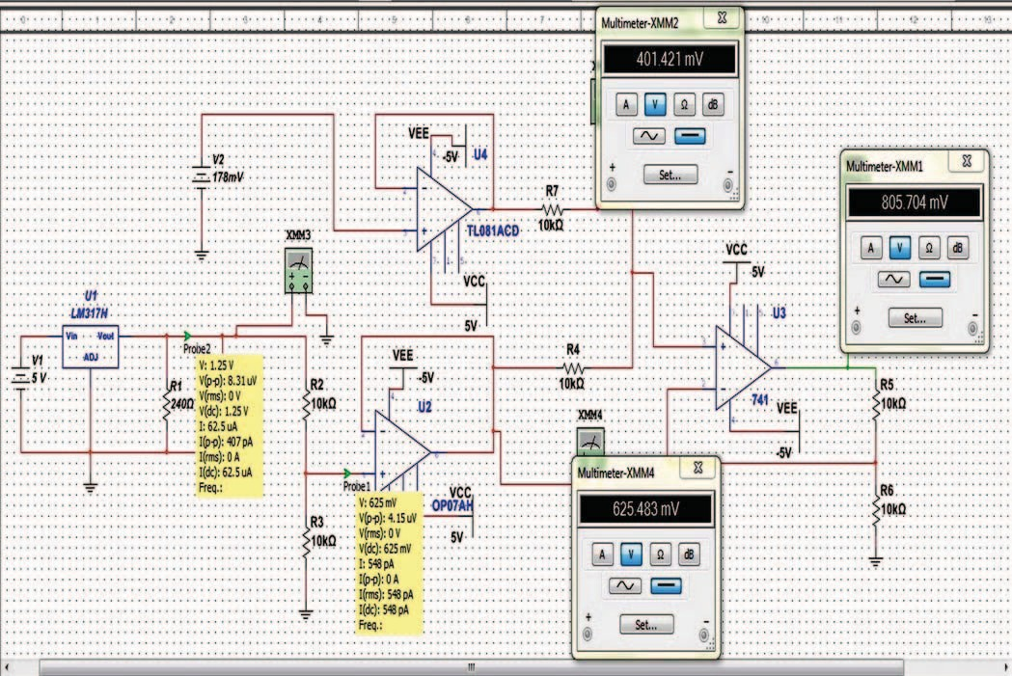

Fig. 9. Output voltages at ph 4

Simulation results for conductivity measurement circuit is represented in Fig. 10. The wein bridge oscillator produces sine wave when input potentiometer is set to 85% and bridge rectifier circuit designed with diodes converts AC signal to DC signal.

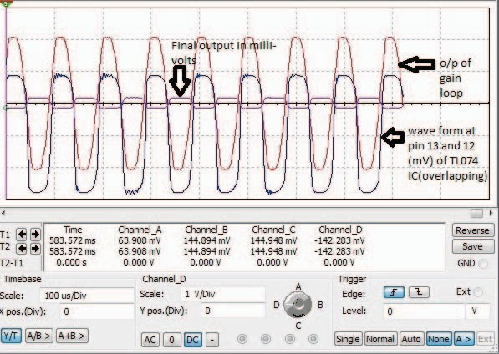Fig. 10. Simulation result for conductivity measurement

1. *Analysis of Hardware Results*

The designed pH measuring circuit’s results were compared to the results obtained using products available in market. Implementation of the results were verified for samples like distilled water, salt water with different concentration of sodium chloride, tap water, dish wash and water, curd, black tea and black coffee. Fig. 11-12 depicts comparison between readings taken by designed pH circuit and a product for distilled water and dish wash in water. From the results, it is proven that both the product from market and designed circuit has stability in readings over its own mean for neutral value of pH.

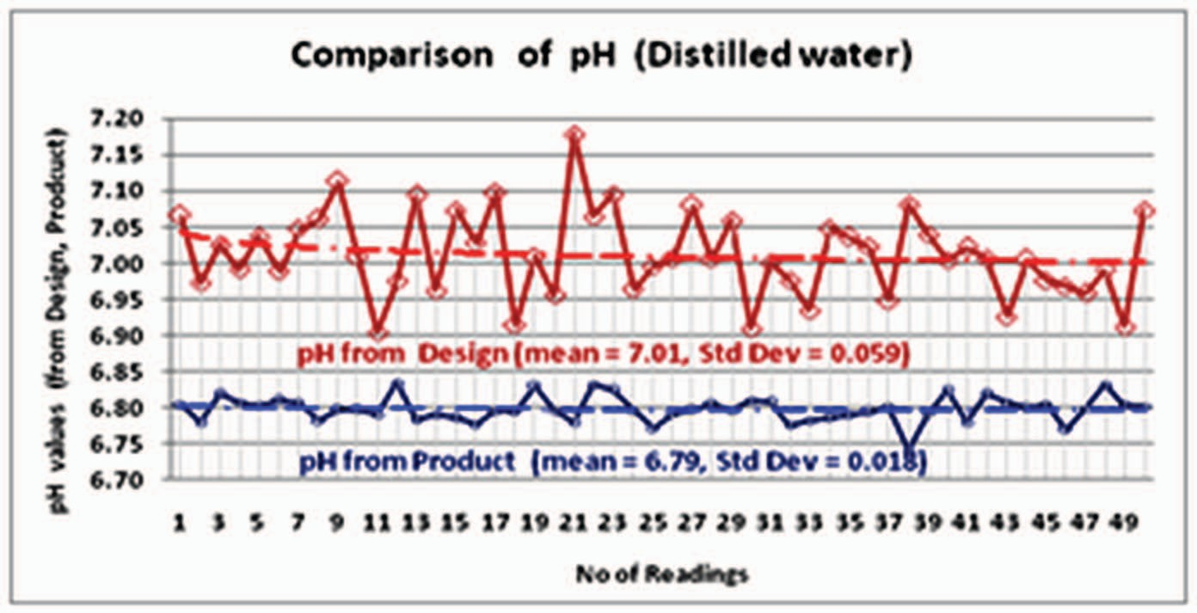

Fig. 11. Comparison for pH of distilled water

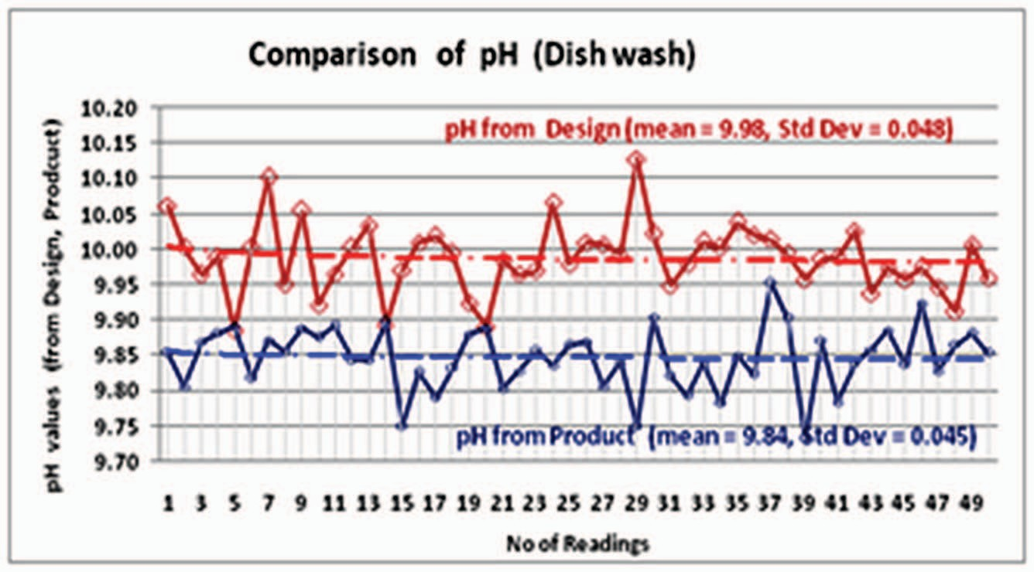

Fig. 12. Comparison for pH of dish wash in water

For lower and higher values of pH, product from market deviates more from the mean value when compared to the developed device. The stability of readings are better throughout the pH range for device but product is stable only at neutral pH. Fig. 13 represents the pH value comparison for design and product with curd of lower pH value.

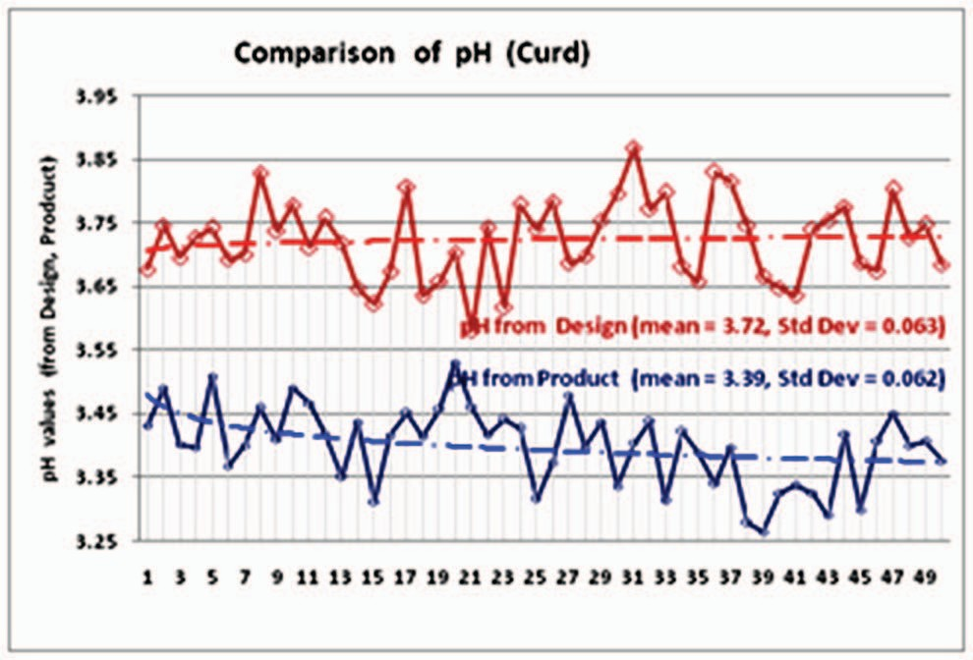

Fig. 13. Comparison of pH for curd

In Fig. 14, the comparison for conductivity measurement was carried out between developed device and product from market. TDS meter from was used and EC was determined using the linear relationship, as in (1). When 2g of salt is mixed with half a litre of water, expected TDS value was 4000 Parts Per Million (PPM) and electrical conductivity was expected around 8V theoretically. The measured value of TDS and conductivity from the designed circuit was found to be

7.92 and 3960 PPM.

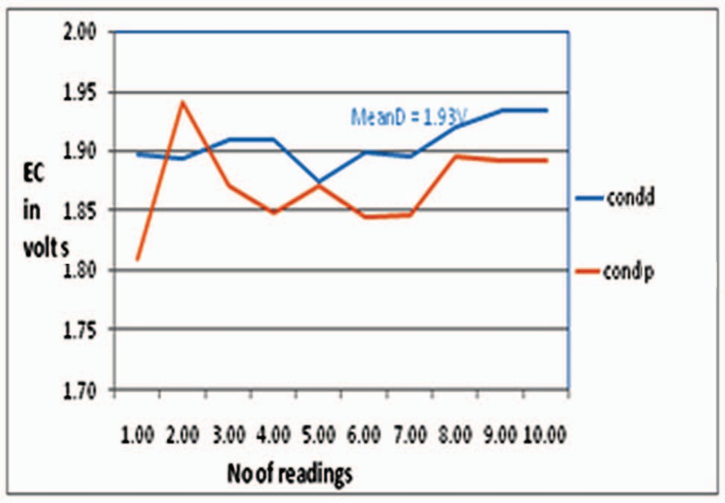

Fig. 14. Comparison of conductivity measurement between the designed device and product from market

The cost for implementing the design had to be compared with the actual products available in foreign as well as indian market to establish that the designed system is low-cost. The bar graph in Fig. 15 represents the comparison in detail. Different companies’ prices in US dollars against the company for pH meters, pH probes alone, conductivity probe and meters.

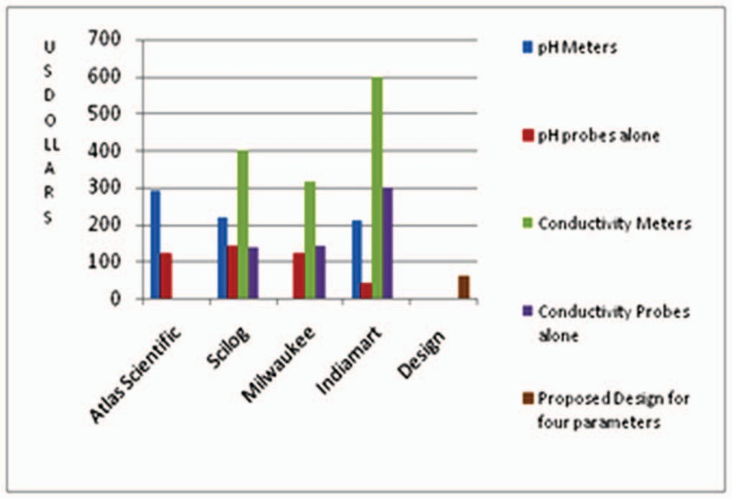

Fig. 15. Cost-wise comparison

Companies compared are Atlas-Scientific, Scilog, Milwaukee and Indiamart. Overall design cost for the developed device was around 60US dollars when compared to the cost of different products available in market varying from 100 – 2000 US dollars.

1. CONCLUSION

In this paper modeling, development and analysis of a low- cost water quality testing device affordable by all is discussed. Modeling of design was carried out on simulation software multisim from national instruments. The circuits were analysed at various stages for comparing the simulation results for different case studies. Implementation was done on hardware and results were compared with available products in market. By comparing pH measurements of design and product, it was found that both results were stable (with a deviation of not more than 0.04) for pH value 7 but at lower and higher pH, the variation in readings was more for product when compared to designed circuit and the mean value was found to be unstable at the lower and higher values of ph for product. Error in conductivity measurement from designed circuit was considerably reduced to 0.07, stable enough without much deviation from mean when compared to the product’s measurement which produces an error of 0.15. TDS of water varies linearly with conductivity, hence designed system gives TDS results with an error of 0.07 compared to commercially available product with error of 0.015. Cost for implementing the design was within 60US$ when compared to products in market which starts from 100US$ to 2000US$.

1. FUTURE RECOMMENDATIONS

The future recommendations are suggested on the basis of the results obtained. Extending the design for measuring parameters like turbidity, chlorine content, fluoride and arsenic content at a lower. Corrective measures to improve the conductivity electrode immersion time can be implemented so that the conductivity measurement can be made faster. Concepts of Internet Of Things (IOT) can be extended for the design to make the design a IOT based water monitoring device.

# Acknowledgment

The authors would like to thank Dr. H. K. Narahari, Dean- FET and Dr. Raghavendra V. Kulkarni, Head of the Department for Computer Science & Engineering for providing all the possible encouragement throughout the work.

# References

1. J. Halder and N. Islam, "Water Pollution and its Impact on the Human Health", Journal of Environment and Human, vol. 2, no. 1, pp. 36-46, 2015.
2. K. Cross and C. Latorre, "Which Water for Which Use? Exploring Water Quality Instruments in the Context of a Changing Climate", Aquatic Procedia, vol. 5, pp. 104-110, 2015.
3. K. Murphy, B. Heery, T. Sullivan, D. Zhang, L. Paludetti, K. Lau, D. Diamond, E. Costa, N. OrConnor and F. Regan, "A low-cost

autonomous optical sensor for water quality monitoring", *Talanta*, vol. 132, pp. 520-527, 2015.

1. Qingping Chi, Hairong Yan, Chuan Zhang, Zhibo Pang and Li Da Xu, "A Reconfigurable Smart Sensor Interface for Industrial WSN in IoT Environment", *IEEE Transactions on Industrial Informatics*, vol. 10, no. 2, pp. 1417-1425, 2014.
2. S. Rathi and R. Gupta, "Sensor Placement Methods for Contamination Detection in Water Distribution Networks: A Review", *Procedia Engineering*, vol. 89, pp. 181-188, 2014.
3. S. Rathi, R. Gupta and L. Ormsbee, "A review of sensor placement objective metrics for contamination detection in water distribution networks", *Water Science & Technology: Water Supply*, vol. 15, no. 5, p. 898, 2015.
4. T. Lambrou, C. Anastasiou, C. Panayiotou and M. Polycarpou, "A Low- Cost Sensor Network for Real-Time Monitoring and Contamination Detection in Drinking Water Distribution Systems", IEEE Sensors Journal, vol. 14, no. 8, pp. 2765-2772, 2014.